

Practices for Secure Software Report

Table of Contents
Document Revision History 3
Client 3
Instructions 3
Developer 4
1. Algorithm Cipher 4
2. Certificate Generation 4
3. Deploy Cipher 4
4. Secure Communications 4
5. Secondary Testing 4
6. Functional Testing 4
7. Summary 4
8. Industry Standard Best Practices 4

Document Revision History

Version | Date | Author | Comments
1.0 | [Date] | [Your Name]

Client



Instructions

Submit this completed practices for secure software report. Replace the bracketed text with the relevant information. You must document your process for writing secure communications and refactoring code that complies with software security testing protocols.

- Respond to the steps outlined below and include your findings.
- Respond using your own words. You may also choose to include images or supporting materials. If you include them, make certain to insert them in all the relevant locations in the document.
- Refer to the Project Two Guidelines and Rubric for more detailed instructions about each section of the template.

Developer
Azaria Berry

Algorithm Cipher

The best recommendation for encrypting long term archive files is AES (Advanced Encryption Standard) with 256–bit keys, combined with secure hashing using SHA-256 for integrity verification. AES with 256-bit keys is an industry standard approved by NIST and is strong against brute force attacks, meaning it is practically unbreakable with current technology. AES–256 is also widely used in Java Cryptography Architecture and is efficient for encrypting large archive files, which is very important when encrypting data for Artemis Financial.

In addition to encryption, SHA-256 hashing is used to ensure data integrity by generating a fixed-length digest of the data. This allows systems to verify that information has not been altered during transmission or storage, which complements AES encryption by providing integrity checking alongside confidentiality.

The purpose of the cipher’s hash functions and bit levels is to ensure the confidentiality, integrity, and overall strength of protected data. A hash function takes an input (such as plain text or a key) and produces a fixed-length output known as a hash value or digest. This output is designed to be computationally infeasible to reverse. In secure systems, hash functions are used to verify that data has not been altered, detect tampering, and securely store sensitive information such as passwords and personal information.

Bit levels such as 128-bit or 256-bit keys refer to the size of the cryptographic key used by the cipher. Larger bit lengths increase the number of possible key combinations, making brute force attacks significantly more difficult. To put this into perspective using mathematical equations, 128-bit has a possibility of 2^128 which is the same as (2 × 2 × 2 × …) 128 times, while 256-bit has a possibility of 2^256 which is the same as (2 × 2 × 2 × …) 256 times. Therefore, a 256-bit key provides exponentially greater security than a 128-bit key, though it may introduce additional computational overhead. Bit levels represent a trade-off between security and performance, while higher bit lengths offer stronger protection at the cost of increased processing requirements.

Random numbers are used to generate secure keys, IVs and nonces, making encryption unpredictable and harder to break. Symmetric encryption uses one shared key for both encryption and decryption and is faster, while asymmetric encryption uses a public and private key pair, making it more secure for key exchange but slower. Most systems use a hybrid approach which combines both for better security and performance. Asymmetric cryptography is used to securely exchange a symmetric key, and symmetric encryption is used for actual data transfer. This approach balances security and performance.

Encryption has come a long way from its early beginnings. Simple methods like the Caesar cipher only shifted letters around and were easy to break once someone recognized the pattern. By the time of World War II, machines such as the German Enigma made encryption much more complex, but they were still eventually cracked. With the rise of computers, encryption became more mathematical, leading to standards like the Data Encryption Standard (DES) in the 1970s. However, DES was later found to be weak against modern attacks and was replaced.

Today, encryption is much more advanced and is built on strong mathematical foundations. AES is commonly used to protect large amounts of data quickly, while SHA-256 is widely used to verify integrity and detect tampering. Methods like RSA help securely exchange keys and verify identities. Encryption is now a core part of everyday technology, helping secure online transactions, communications, and stored data. Ongoing research is focused on improving security and efficiency, especially as new challenges like quantum computing could threaten current encryption methods.

Certificate Generation
Insert a screenshot below of the CER file.

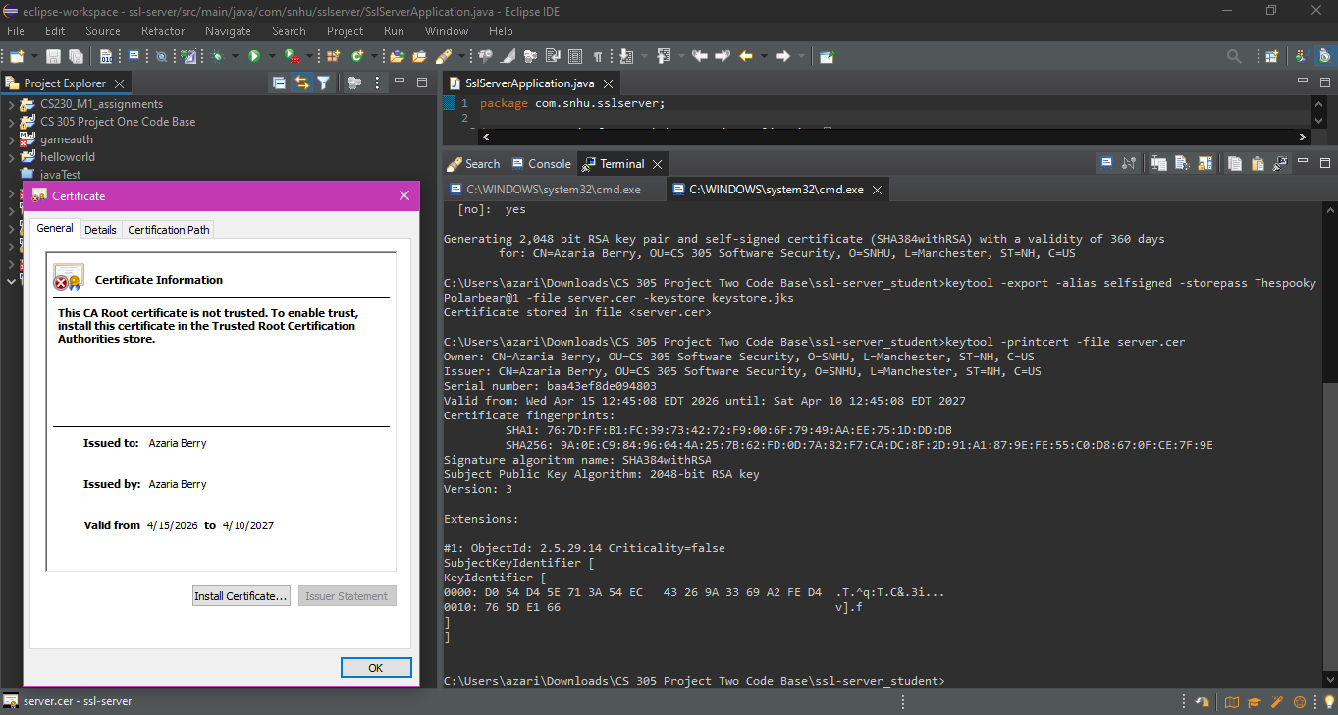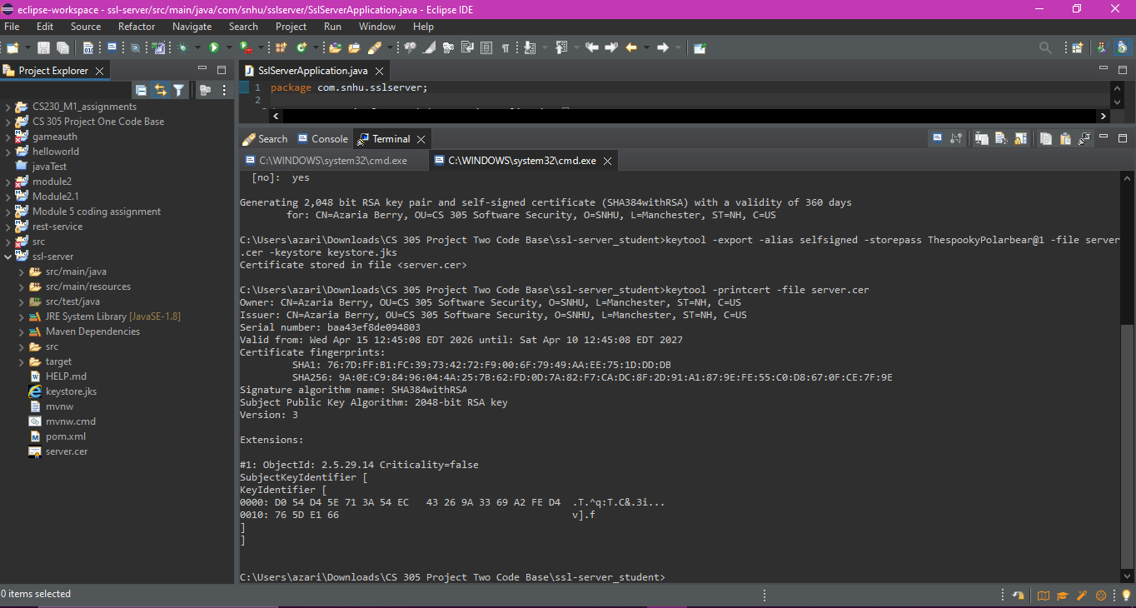

Deploy Cipher
Insert a screenshot below of the checksum verification.



Secure Communications
Insert a screenshot below of the web browser that shows a secure webpage.
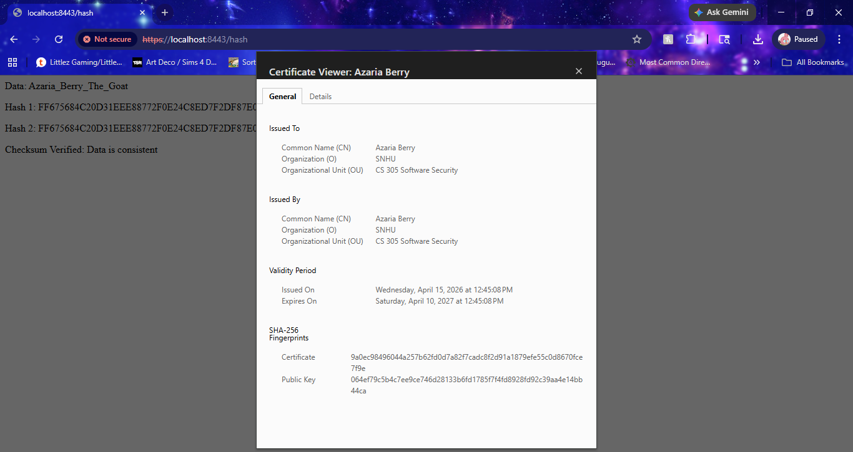

Secondary Testing
Insert screenshots below of the refactored code executed without errors and the dependency-check report.

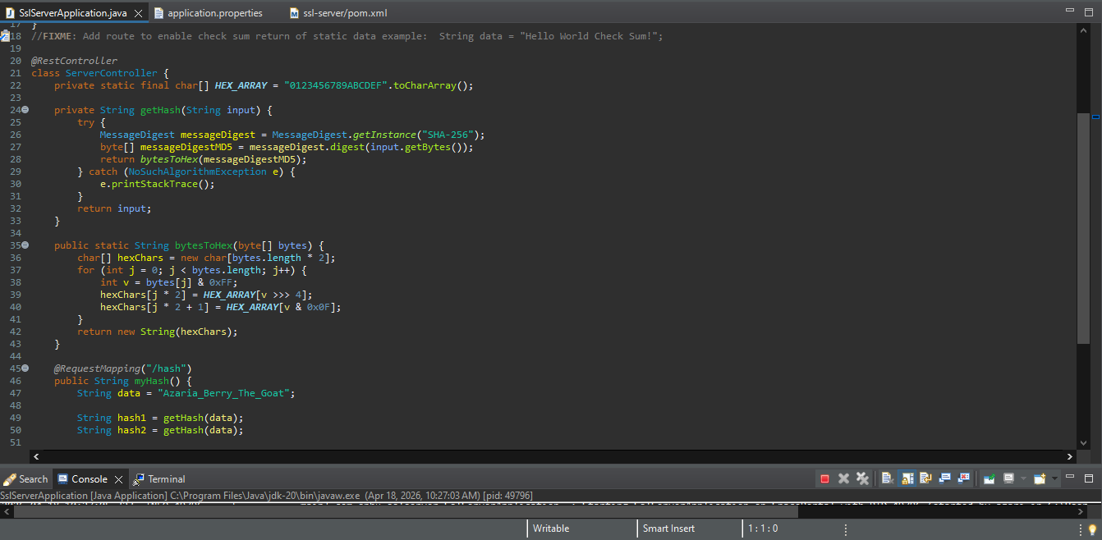
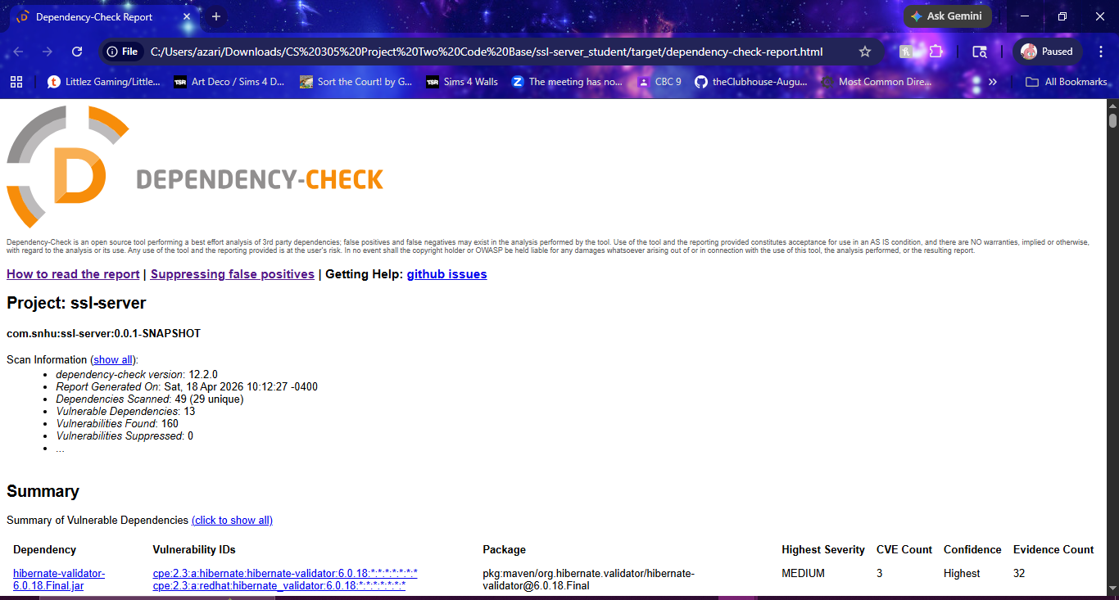

Functional Testing
Insert a screenshot below of the refactored code executed without errors. 
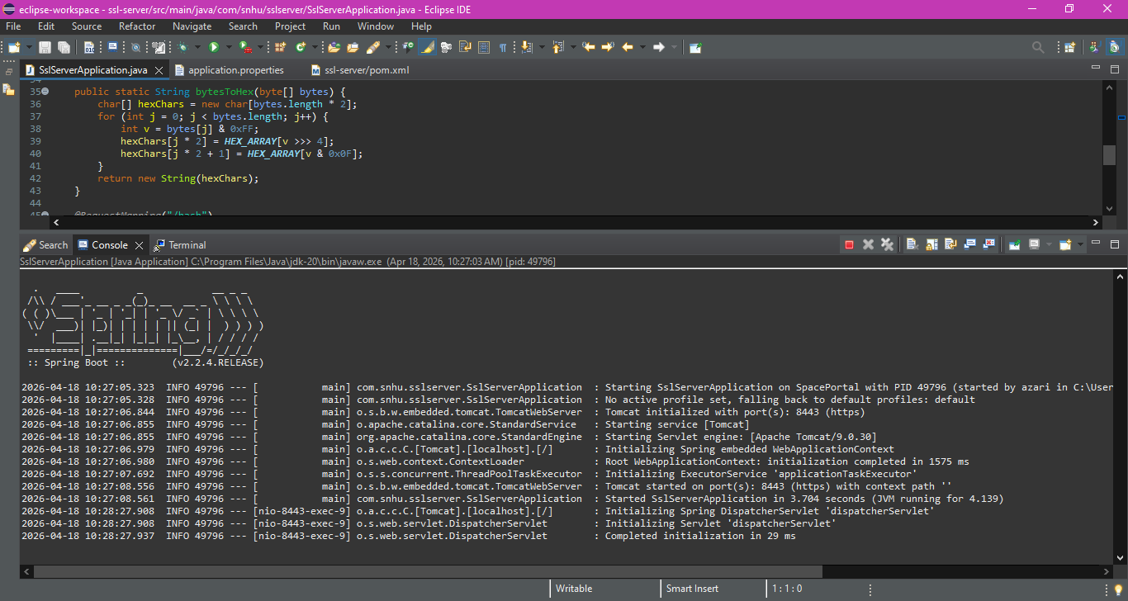

Summary

I refactored the application using the Vulnerability Assessment Process Flow as a guide to improve security and ensure it meets secure software practices. During the architecture review, the structure of the Spring Boot application was examined to make sure responsibilities were properly separated, especially within the controller handling the /hash endpoint. In the cryptography stage, a SHA-256 hashing function was added to generate a checksum from a data string, which helps confirm data integrity and detect any tampering. For the client/server portion, the application was updated to use HTTPS by configuring a keystore and self-signed certificate, allowing encrypted communication between the browser and the server.

Code quality and error handling were also reviewed to fix logical issues, such as ensuring the hashing function correctly processes the input string rather than returning an empty or incorrect value. Static testing was completed using the OWASP Dependency-Check tool to check for known vulnerabilities in project dependencies, and the results showed that no additional issues were introduced after refactoring. The overall process followed a layered approach to security: identifying weaknesses, applying fixes like hashing and HTTPS, and then verifying those changes through testing. This combination of steps strengthens the application by addressing multiple areas of the assessment process rather than relying on a single security measure.

Industry Standard Best Practices

Industry standard best practices for secure coding were applied throughout the refactoring process to maintain and improve the application’s security. One key practice was the use of strong, widely accepted cryptographic standards by implementing SHA-256 for hashing, which helps ensure data integrity and prevents tampering. In addition, secure communication protocols were enforced by configuring HTTPS with a keystore and self-signed certificate, protecting data in transit. The code was also reviewed for logical and syntactical issues to ensure it functions correctly and does not introduce unintended vulnerabilities. Static analysis was performed using the OWASP Dependency-Check tool to identify any known security risks in project dependencies, ensuring that existing security was maintained while also verifying that no new vulnerabilities were introduced during the refactoring process.

Applying these industry standard best practices provides significant value to the company’s overall well-being. Secure coding reduces the risk of data breaches, protects sensitive information, and helps maintain customer trust. It also minimizes potential financial losses and legal consequences that can result from security incidents. By following established security practices, the organization ensures that its software remains reliable, resilient, and aligned with modern security expectations.

